**The radio button list is pre-defined**

Before we move on, I want to answer 2 common questions.

**#1. Why are radio buttons called “radio” buttons?**

Basically it boils down to old car radios.

In the early days of car radios, the common convention was to provide the user with a few buttons under the dial that could mechanically store presets, so the user didn't need to fiddle with the tuning dial to find a station. In some models, pressing one of these buttons would cause it to stay down until another was pressed. In other words, only one could be pressed at any given time.

**Bottom line: HTML radio buttons were named after the physical buttons used on car radios to select preset stations.**

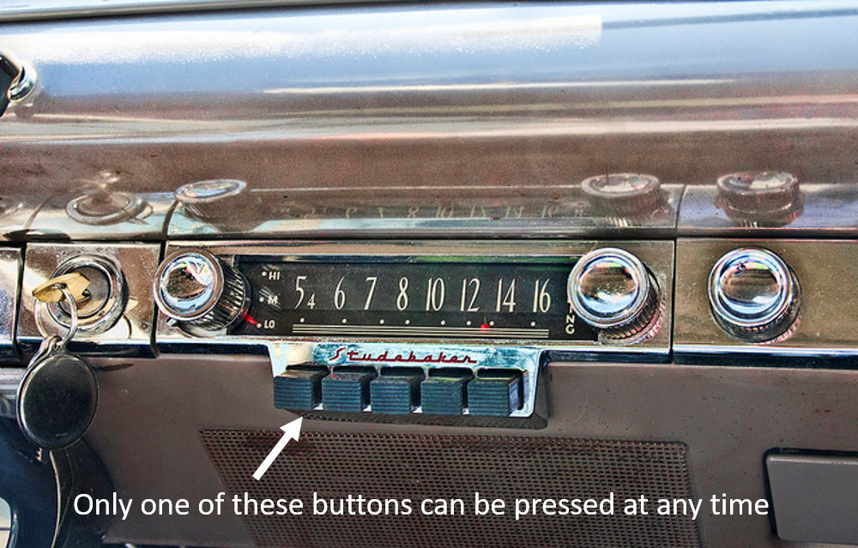

*HTML radio buttons are named after old-school car radio buttons*

**#2. How to allow the user to input their own values in a radio list?**

Short answer = you can't.

You’ll notice with the radio buttons, that the list is pre-defined.

Huh?

I mean that the user can’t add a different value to the list of radio buttons. We define the list in our HTML code and we basically force one selection from our group.

This can be useful right?

If your hotel only has a budget room, standard room and executive suite, then having a radio selection with ONLY these 3 room types makes sense.

But sometimes you want the user to enter their own values, right?

Remember that right now in the course, we are only dealing with the <input> element in this section.

In later sections, when we move away from the <input> element, I’ll show you how to utilize other (more advanced and modern) dropdown controls like **select** and **autocomplete**dropdowns. These other techniques do allow custom user input.

I'll also show you how to create a dynamic **datalist**dropdown.

Very exciting.

But I don't want to push the cart before the horse.

Let's jump back into the lectures.